VISVESVARAYA TECHNOLOGICAL UNIVERSITY

“JnanaSangama”, Belgaum -590014, Karnataka.


LAB REPORT

On
ANALYSIS AND DESIGN OF ALGORITHMS (23CS4PCADA)

Submitted by
Manshi Kumari (1BF24CS167)

in partial fulfillment for the award of the degree of BACHELOR OF ENGINEERING
in
COMPUTER SCIENCE AND ENGINEERING


B.M.S. COLLEGE OF ENGINEERING
(Autonomous Institution under VTU) BENGALURU-560019
February to June 2026

CERTIFICATE

B. M. S. College of Engineering,
Bull Temple Road, Bangalore 560019
(Affiliated To Visvesvaraya Technological University, Belgaum) Department of Computer Science and Engineering



This is to certify that the Lab work entitled “ANALYSIS AND DESIGN OF ALGORITHMS” carried out by Manshi Kumari (1BF24CS167), who is bonafide student of B. M. S. College of Engineering. It is in partial fulfillment for the award of Bachelor of Engineering in Computer Science and Engineering of the Visvesvaraya Technological University, Belgaum during the year 2025-26. The Lab report has been approved as it satisfies the academic requirements in respect of Analysis and Design of Algorithms Lab - (23CS4PCADA) work prescribed for the said degree.

Prof. Manjula S Dr. Kavitha Sooda
Assistant Professor Professor and Head
Department of CSE Department of CSE
BMSCE, Bengaluru BMSCE, Bengaluru

Index Sheet

Sl.  No. | Experiment Title | Page No.
1 | Write program to obtain the Topological ordering of vertices in a given digraph. | 4-8
2 | Implement Johnson Trotter algorithm to generate permutations. | 9-11
3 | Sort a given set of N integer elements using Merge Sort technique and  compute its time taken. Run the program for different values of N and record the time taken to sort. | 12-17
4 | Sort a given set of N integer elements using Quick Sort technique and compute its time taken. | 18-22
5 | Sort a given set of N integer elements using Heap Sort technique and compute its time taken. | 23-25
6 | Implement 0/1 Knapsack problem using dynamic programming. (5 Marks) | 26-29
7 | Implement All Pair Shortest paths problem using Floyd’s algorithm. | 30-34
8 | - Find Minimum Cost Spanning Tree of a given undirected graph using Prim’s algorithm.  - Find Minimum Cost Spanning Tree of a given undirected graph using Kruskal’s algorithm. | 35-41
9 | Implement Fractional Knapsack using Greedy technique. | 42-45
10 | From a given vertex in a weighted connected graph, find shortest paths to other vertices using Dijkstra’s algorithm. | 46-48
11 | Implement “N-Queens Problem” using Backtracking. | 49-51

Course outcomes:

CO1 | Analyze time complexity of algorithms using asymptotic notations.
CO2 | Apply various algorithm design techniques for the given problem.
CO3 | Evaluate the appropriate algorithm/design technique for solving a given problem.
CO4 | Conduct practical experiments by applying appropriate algorithm design technique to solve problems.

Lab program 1:
Write program to obtain the Topological ordering of vertices in a given digraph.

#include <stdio.h> #define MAX 100
int graph[MAX][MAX]; int visited[MAX];
int stack[MAX]; int top = -1;

void dfs(int v, int n) { visited[v] = 1;
for(int i = 0; i < n; i++) {

if(graph[v][i] && !visited[i]) { dfs(i, n);
}
}

stack[++top] = v;
}

void topologicalSort(int n) { for(int i = 0; i < n; i++) {
if(!visited[i]) { dfs(i, n);
}
}
printf("Topological Ordering:\n"); while(top != -1) {
printf("%d ", stack[top--]);
}
}

int main() { int n, e;
printf("Enter number of vertices: "); scanf("%d", &n);

printf("Enter number of edges: "); scanf("%d", &e);

printf("Enter edges (u v):\n"); for(int i = 0; i < e; i++) {
int u, v;

scanf("%d %d", &u, &v);

graph[u][v] = 1;
}

topologicalSort(n);

return 0;
}

Output:

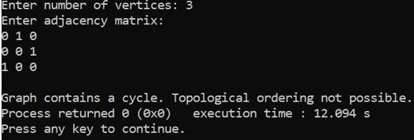

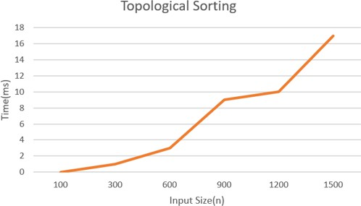

Leetcode: 207. Course Schedule

#include <stdbool.h> #include <stdlib.h>

bool canFinish(int numCourses, int** prerequisites, int prerequisitesSize, int* prerequisitesColSize) {
int indegree[numCourses];

// Initialize indegree to 0
for(int i = 0; i < numCourses; i++) { indegree[i] = 0;
}

// Create adjacency matrix
int adj[numCourses][numCourses];

for(int i = 0; i < numCourses; i++) { for(int j = 0; j < numCourses; j++) {
adj[i][j] = 0;
}
}

// Build graph and indegree
for(int i = 0; i < prerequisitesSize; i++) { int a = prerequisites[i][0];
int b = prerequisites[i][1];

adj[b][a] = 1; indegree[a]++;
}

// Queue
int queue[numCourses]; int front = 0, rear = 0;

// Push nodes with indegree 0 for(int i = 0; i < numCourses; i++) {
if(indegree[i] == 0) { queue[rear++] = i;
}
}
int count = 0; while(front < rear) {
int node = queue[front++];

count++;
for(int i = 0; i < numCourses; i++) { if(adj[node][i] == 1) {
indegree[i]--;

if(indegree[i] == 0) { queue[rear++] = i;
}
}
}
}

return count == numCourses;
}}

Output:

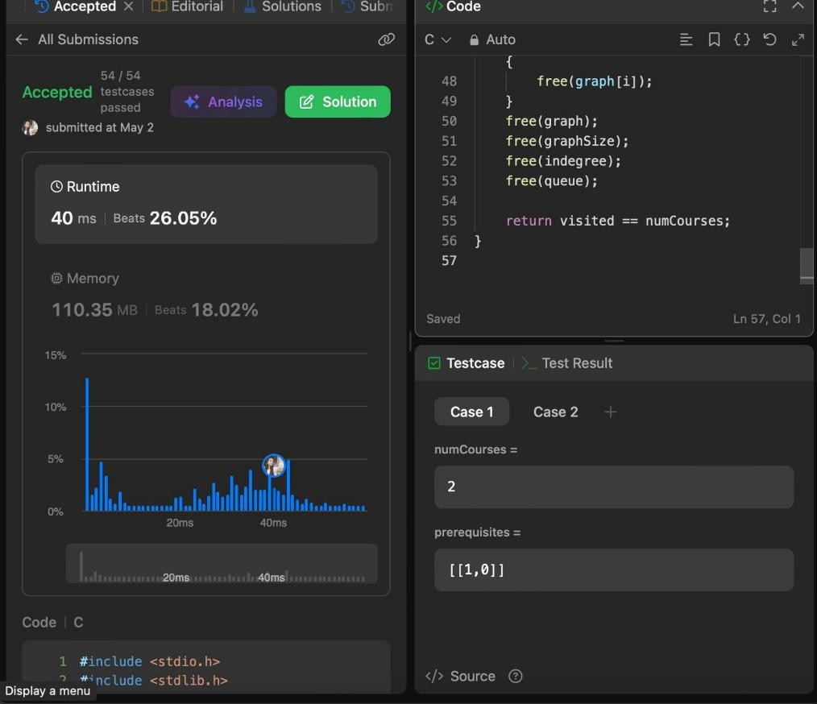

Lab program 2:
Implement Johnson Trotter algorithm to generate permutations
#include <stdio.h>

#define LEFT 0
#define RIGHT 1

void print(int a[], int dir[], int n)
{
for(int i = 0; i < n; i++)
{
if(dir[a[i]] == LEFT) printf("%d<- ", a[i]);
else
printf("%d-> ", a[i]);
}
printf("\n");
}

int getMobile(int a[], int dir[], int n)
{
int mobile = 0;

for(int i = 0; i < n; i++)
{
if(dir[a[i]] == LEFT && i > 0)
{
if(a[i] > a[i-1] && a[i] > mobile) mobile = a[i];
}

if(dir[a[i]] == RIGHT && i < n-1)
{
if(a[i] > a[i+1] && a[i] > mobile) mobile = a[i];
}
}
return mobile;
}

int findPos(int a[], int n, int mobile)

{
for(int i = 0; i < n; i++)
{
if(a[i] == mobile) return i;
}
return -1;
}

void johnsonTrotter(int n)
{
int a[n], dir[n+1];

for(int i = 0; i < n; i++)
{
a[i] = i + 1;
dir[i + 1] = LEFT;
}
print(a, dir, n); while(1)
{
int mobile = getMobile(a, dir, n);

if(mobile == 0) break;
int pos = findPos(a, n, mobile); if(dir[mobile] == LEFT)
{
int temp = a[pos]; a[pos] = a[pos - 1]; a[pos - 1] = temp; pos = pos - 1;
}
else
{
int temp = a[pos]; a[pos] = a[pos + 1]; a[pos + 1] = temp;

pos = pos + 1;
}

for(int i = 1; i <= n; i++)
{
if(i > mobile) dir[i] = !dir[i];
}

print(a, dir, n);
}
}

int main()
{
int n;

printf("Enter n: ");
scanf("%d", &n); johnsonTrotter(n);
return 0;
}

Output:

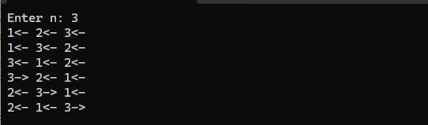

Lab program 3:
Sort a given set of N integer elements using Merge Sort technique and compute its time taken. Run the program for different values of N and record the time taken to sort.
#include <stdio.h> #include <stdlib.h> #include <time.h>
void merge(int arr[], int lb, int mid, int ub)
{
int n1 = mid - lb + 1; int n2 = ub - mid;

int L[n1], R[n2];

for (int i = 0; i < n1; i++) L[i] = arr[lb + i];

for (int j = 0; j < n2; j++) R[j] = arr[mid + 1 + j];
int i = 0, j = 0, k = lb; while (i < n1 && j < n2)
{
if (L[i] <= R[j])
arr[k++] = L[i++]; else
arr[k++] = R[j++];
}

while (i < n1) arr[k++] = L[i++];

while (j < n2) arr[k++] = R[j++];
}

void mergeSort(int arr[], int lb, int ub)
{
if (lb < ub)
{
int mid = (lb + ub) / 2;

mergeSort(arr, lb, mid); mergeSort(arr, mid + 1, ub);

merge(arr, lb, mid, ub);
}
}

int main()
{
int n;

printf("Enter number of elements: "); scanf("%d", &n);

int arr[n];
printf("Enter elements:\n"); for (int i = 0; i < n; i++)
scanf("%d", &arr[i]); clock_t start = clock(); mergeSort(arr, 0, n - 1); clock_t end = clock();
double time_taken = (double)(end - start) / CLOCKS_PER_SEC; printf("\nSorted array:\n");
for (int i = 0; i < n; i++) printf("%d ", arr[i]);

printf("\n");

printf("Time taken: %.6f seconds\n", time_taken);

return 0;
}

Output:

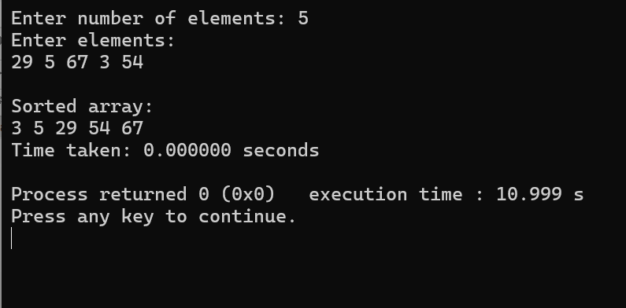

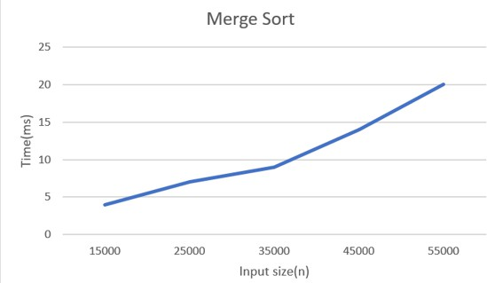

Leetcode 912: Sort an array

#include <stdlib.h>

void merge(int nums[], int left, int mid, int right)
{
int n1 = mid - left + 1; int n2 = right - mid;

int L[n1], R[n2];

for(int i = 0; i < n1; i++) L[i] = nums[left + i];

for(int j = 0; j < n2; j++) R[j] = nums[mid + 1 + j];
int i = 0, j = 0, k = left; while(i < n1 && j < n2)
{
if(L[i] <= R[j])
{
nums[k] = L[i]; i++;
}
else
{
nums[k] = R[j]; j++;
}
k++;
}

while(i < n1)
{
nums[k] = L[i]; i++;
k++;
}

while(j < n2)
{
nums[k] = R[j]; j++;
k++;
}
}

void mergesort(int nums[], int left, int right)
{
if(left < right)
{
int mid = left + (right - left) / 2;

mergesort(nums, left, mid); mergesort(nums, mid + 1, right);

merge(nums, left, mid, right);
}
}

int* sortArray(int* nums, int numsSize, int* returnSize)
{
mergesort(nums, 0, numsSize - 1);

*returnSize = numsSize;

return nums;
}

Output:

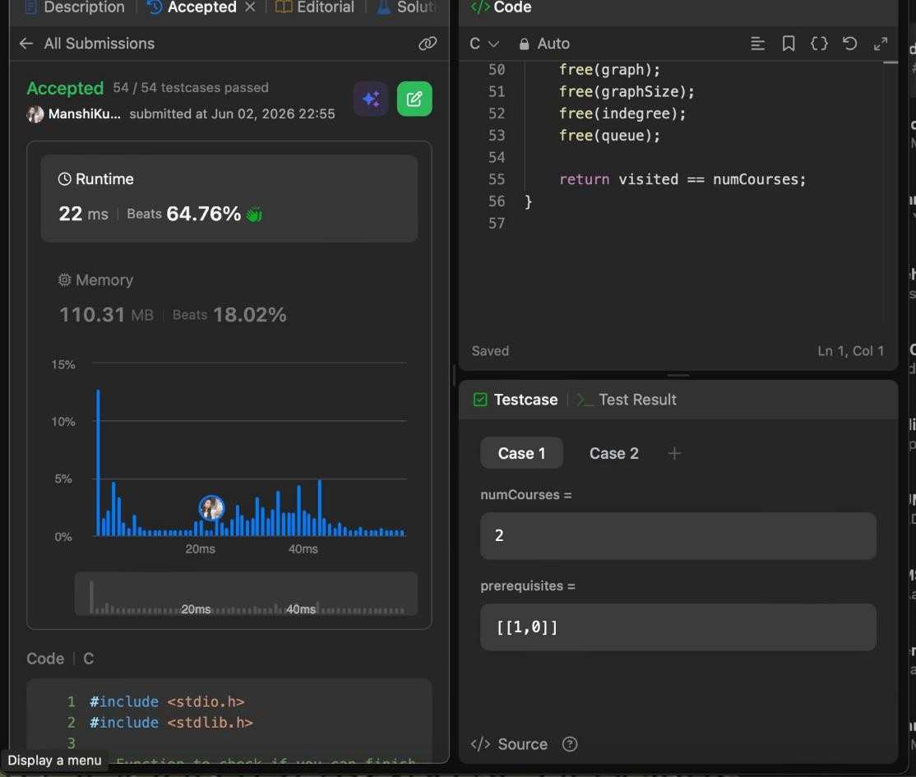

Lab program 4:
Sort a given set of N integer elements using Quick Sort technique and compute its time taken.
#include <stdio.h> #include <stdlib.h> #include <time.h>

void swap(int *a, int *b)
{
int temp = *a;
*a = *b;
*b = temp;
}

int partition(int arr[], int low, int high)
{
int pivot = arr[high]; int i = (low - 1);

for (int j = low; j < high; j++)
{
if (arr[j] <= pivot)
{
i++;
swap(&arr[i], &arr[j]);
}
}

swap(&arr[i + 1], &arr[high]); return (i + 1);
}

void quickSort(int arr[], int low, int high)
{
if (low < high)
{
int pi = partition(arr, low, high);

quickSort(arr, low, pi - 1); quickSort(arr, pi + 1, high);
}
}

int main()
{
int N;

printf("Enter number of elements: "); scanf("%d", &N);

int arr[N];
printf("Enter the elements:\n"); for (int i = 0; i < N; i++)
{
scanf("%d", &arr[i]);
}

clock_t start, end; start = clock();
quickSort(arr, 0, N - 1); end = clock(); printf("Sorted array:\n");
for (int i = 0; i < N; i++)
{
printf("%d ", arr[i]);
}

double time_taken = ((double)(end - start)) / CLOCKS_PER_SEC; printf("\nTime taken: %f seconds\n", time_taken);
return 0;
}

Output:

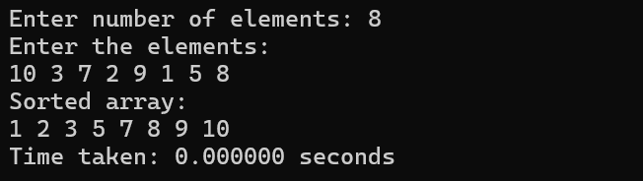

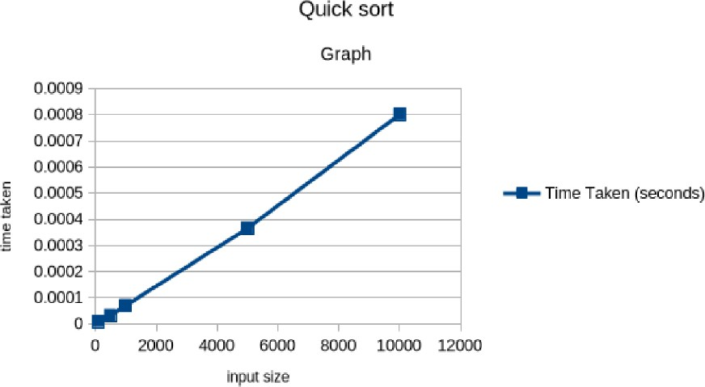

Leetcode 207: Course Schedule

#include <stdio.h> #include <stdlib.h>

// Function to check if you can finish all courses
int canFinish(int numCourses, int** prerequisites, int prerequisitesSize, int* prerequisitesColSize) {
// Build graph adjacency list
int* indegree = (int*)calloc(numCourses, sizeof(int)); int** graph = (int**)malloc(numCourses * sizeof(int*)); int* graphSize = (int*)calloc(numCourses, sizeof(int));

for (int i = 0; i < numCourses; i++) {
graph[i] = (int*)malloc(numCourses * sizeof(int)); // worst case
}

for (int i = 0; i < prerequisitesSize; i++) { int course = prerequisites[i][0];
int prereq = prerequisites[i][1]; graph[prereq][graphSize[prereq]++] = course; indegree[course]++;
}

// Queue for BFS
int* queue = (int*)malloc(numCourses * sizeof(int)); int front = 0, rear = 0;

// Add courses with indegree 0
for (int i = 0; i < numCourses; i++) { if (indegree[i] == 0) {
queue[rear++] = i;
}
}

int visited = 0;
while (front < rear) {
int node = queue[front++]; visited++;
for (int i = 0; i < graphSize[node]; i++) { int neighbor = graph[node][i]; indegree[neighbor]--;
if (indegree[neighbor] == 0) { queue[rear++] = neighbor;

}
}
}

// Free memory
for (int i = 0; i < numCourses; i++) { free(graph[i]);
}
free(graph); free(graphSize); free(indegree); free(queue);

return visited == numCourses;
}

Output:

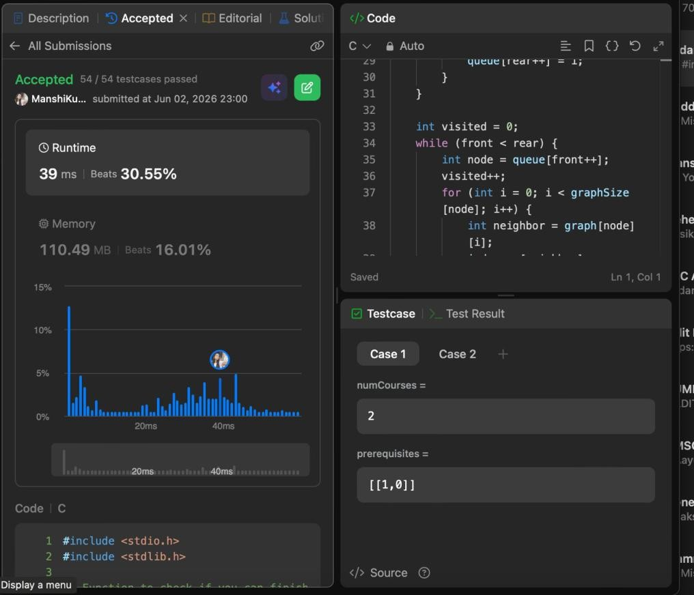

Lab program 5:
Sort a given set of N integer elements using Heap Sort technique and compute its time taken.
#include <stdio.h>

void swap(int *a, int *b)
{
int temp = *a;
*a = *b;
*b = temp;
}

void siftUp(int a[], int i)
{
while(i > 0)
{
int parent = (i - 1) / 2;

if(a[parent] < a[i])
{
swap(&a[parent], &a[i]); i = parent;
}
else
{
break;
}
}
}

void buildHeap(int a[], int n)
{
for(int i = 1; i < n; i++)
{
siftUp(a, i);
}
}

void heapify(int a[], int n, int i)
{
int largest = i;
int left = 2 * i + 1;

int right = 2 * i + 2;

if(left < n && a[left] > a[largest]) largest = left;

if(right < n && a[right] > a[largest]) largest = right;

if(largest != i)
{
swap(&a[i], &a[largest]); heapify(a, n, largest);
}
}

void heapSort(int a[], int n)
{
buildHeap(a, n);

for(int i = n - 1; i > 0; i--)
{
swap(&a[0], &a[i]); heapify(a, i, 0);
}
}

void print(int a[], int n)
{
for(int i = 0; i < n; i++) printf("%d ", a[i]);

printf("\n");
}

int main()
{
int n;

printf("Enter n: ");
scanf("%d", &n); int a[n];

printf("Enter elements:\n");

for(int i = 0; i < n; i++) scanf("%d", &a[i]);

heapSort(a, n);

printf("Sorted array:\n"); print(a, n);

return 0;
}

Output:

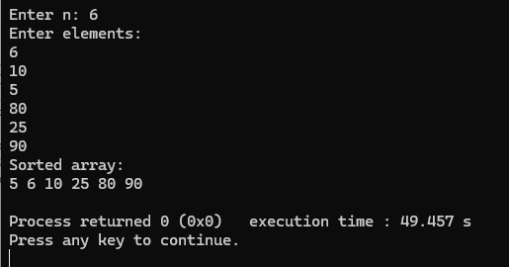

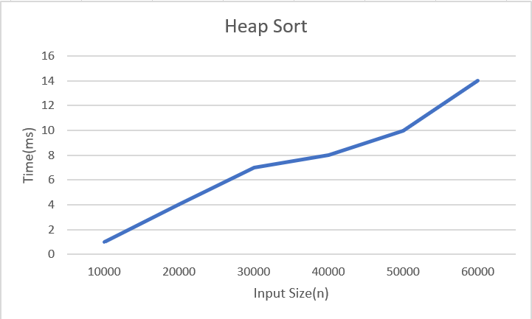

Lab program 6:
Implement 0/1 Knapsack problem using dynamic programming.

#include <stdio.h>

int knapsack(int W, int wt[], int val[], int n)
{
int dp[n+1][W+1];

for (int i = 0; i <= n; i++)
{
for (int w = 0; w <= W; w++)
{
if (i == 0 || w == 0)
{
dp[i][w] = 0;
}
else if (wt[i-1] <= w)
{
int include = val[i-1] + dp[i-1][w - wt[i-1]]; int exclude = dp[i-1][w];

dp[i][w] = (include > exclude) ? include : exclude;
}
else
{
dp[i][w] = dp[i-1][w];
}
}
}

int selected[n];

for (int i = 0; i < n; i++) selected[i] = 0;

int i = n; int w = W;

while (i > 0 && w > 0)
{

if (dp[i][w] != dp[i-1][w])
{
selected[i-1] = 1; w = w - wt[i-1];
}

i--;
}
printf("\nItems included in Knapsack:\n"); for (int i = 0; i < n; i++)
{
printf("%d ", selected[i]);
}

printf("\n");

return dp[n][W];
}

int main()
{
int n, W;

printf("Enter number of items: "); scanf("%d", &n);

int val[n], wt[n];

printf("Enter profit of items:\n"); for (int i = 0; i < n; i++)
{
scanf("%d", &val[i]);
}

printf("Enter weights of items:\n"); for (int i = 0; i < n; i++)
{
scanf("%d", &wt[i]);
}

printf("Enter knapsack capacity: ");

scanf("%d", &W);

int result = knapsack(W, wt, val, n); printf("\nMaximum value in Knapsack = %d\n", result);
return 0;
}

Output:

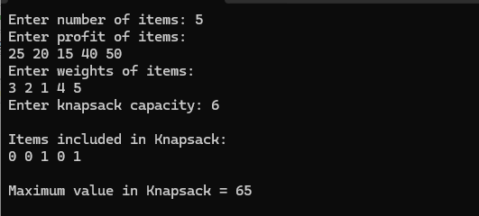

Leetcode : 518. Coin Change II

int change(int amount, int* coins, int coinsSize) { unsigned long long dp[amount + 1];
for(int i = 0; i <= amount; i++){ dp[i] = 0;
}

dp[0] = 1;

for(int i = 0; i < coinsSize; i++){
for(int j = coins[i]; j <= amount; j++){ dp[j] = dp[j] + dp[j - coins[i]];
}
}

return (int)dp[amount];
}

Output:
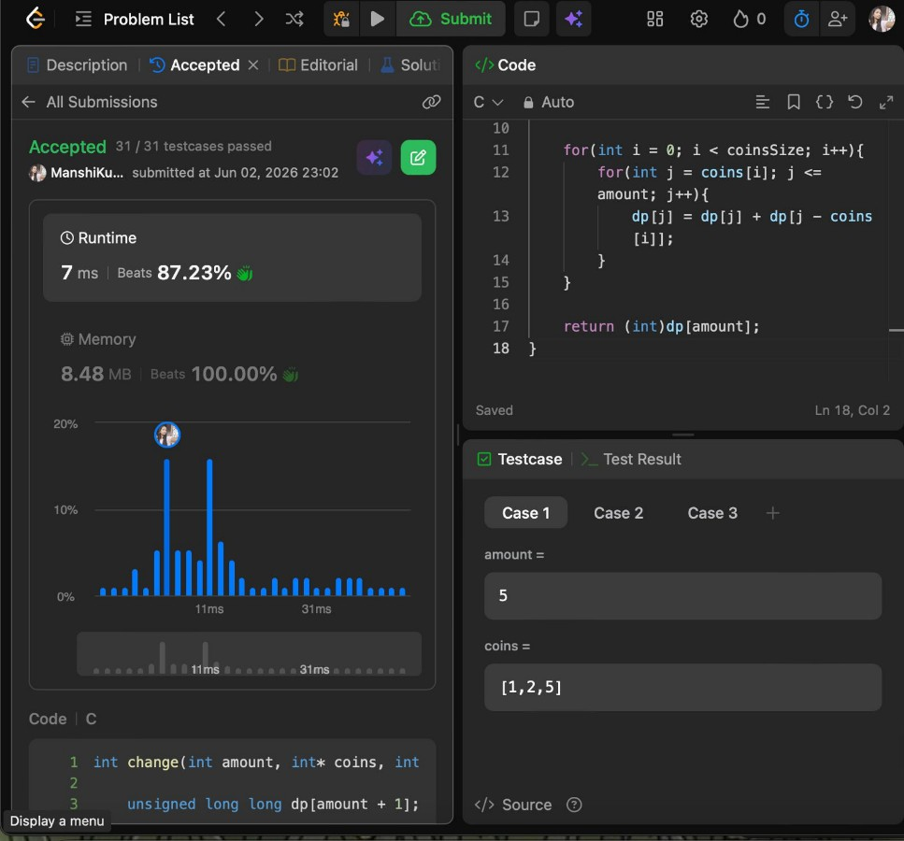

Lab program 7:
Implement All Pair Shortest paths problem using Floyd’s algorithm.
#include <stdio.h>

#define INF 99999
#define MAX 100

void printSolution(int dist[MAX][MAX], int V)
{
printf("\nShortest distance matrix:\n");

for (int i = 0; i < V; i++)
{
for (int j = 0; j < V; j++)
{
if (dist[i][j] == INF)
printf("%7s", "INF"); else
printf("%7d", dist[i][j]);
}
printf("\n");
}
}

void floydWarshall(int graph[MAX][MAX], int V)
{
int dist[MAX][MAX];

for (int i = 0; i < V; i++) for (int j = 0; j < V; j++)
dist[i][j] = graph[i][j];

for (int k = 0; k < V; k++)
{
for (int i = 0; i < V; i++)
{
for (int j = 0; j < V; j++)
{
if (dist[i][k] < INF && dist[k][j] < INF &&
dist[i][k] + dist[k][j] < dist[i][j])
{

dist[i][j] = dist[i][k] + dist[k][j];
}
}
}
}

for (int i = 0; i < V; i++)
{
if (dist[i][i] < 0)
{
printf("\nNegative cycle detected!\n"); return;
}
}

printSolution(dist, V);
}

int main()
{
int V;
int graph[MAX][MAX];

printf("Enter number of vertices: "); scanf("%d", &V);
printf("\nEnter adjacency matrix (-1 for no edge):\n"); for (int i = 0; i < V; i++)
{
for (int j = 0; j < V; j++)
{
scanf("%d", &graph[i][j]);

if (graph[i][j] == -1)
graph[i][j] = INF;
}
}

for (int i = 0; i < V; i++) graph[i][i] = 0;

floydWarshall(graph, V);

return 0;
}

Output:

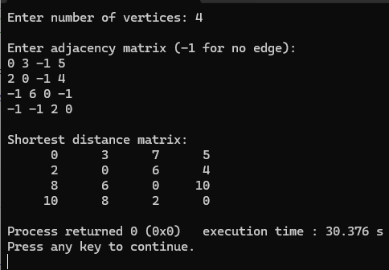

Leetcode 1334: Find the city with the smallest no of neighbors at a threshold distance

#include <limits.h>

int findTheCity(int n, int** edges, int edgesSize, int* edgesColSize, int distanceThreshold) { int dist[101][101];
// Initialize matrix for(int i = 0; i < n; i++){
for(int j = 0; j < n; j++){ if(i == j)
dist[i][j] = 0; else
dist[i][j] = INT_MAX / 2;
}
}

// Fill edge weights
for(int i = 0; i < edgesSize; i++){ int u = edges[i][0];
int v = edges[i][1]; int w = edges[i][2];

dist[u][v] = w;
dist[v][u] = w;
}

// Floyd Warshall
for(int k = 0; k < n; k++){ for(int i = 0; i < n; i++){
for(int j = 0; j < n; j++){
if(dist[i][j] > dist[i][k] + dist[k][j]){
dist[i][j] = dist[i][k] + dist[k][j];
}
}
}
}

int city = -1;
int minCount = INT_MAX;

// Count reachable cities for(int i = 0; i < n; i++){
int count = 0;

for(int j = 0; j < n; j++){
if(i != j && dist[i][j] <= distanceThreshold){ count++;
}
}

if(count <= minCount){ minCount = count; city = i;
}
}

return city;
}

Output:
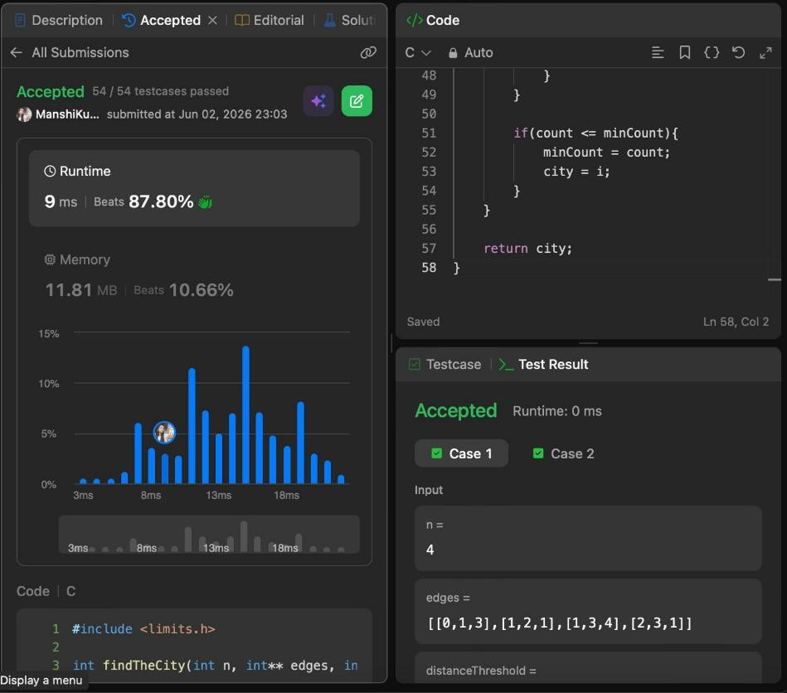

Lab program 8a:
Find Minimum Cost Spanning Tree of a given undirected graph using Prim’s
algorithm.

#include <stdio.h> #include <limits.h>

int minKey(int key[], int mstSet[], int V)
{
int min = INT_MAX, min_index = -1;

for (int v = 0; v < V; v++)
if (mstSet[v] == 0 && key[v] < min) min = key[v], min_index = v;

return min_index;
}

void primMST(int graph[50][50], int V)
{
int parent[V], key[V], mstSet[V]; int totalCost = 0;

for (int i = 0; i < V; i++)
{
key[i] = INT_MAX; mstSet[i] = 0;
}

key[0] = 0;
parent[0] = -1;

for (int count = 0; count < V - 1; count++)
{
int u = minKey(key, mstSet, V); mstSet[u] = 1;

for (int v = 0; v < V; v++)
{
if (graph[u][v] && mstSet[v] == 0 && graph[u][v] < key[v])
{

parent[v] = u;
key[v] = graph[u][v];
}
}
}
printf("\nEdges in MST:\n"); for (int i = 1; i < V; i++)
{
printf("%d - %d : %d\n", parent[i], i, graph[i][parent[i]]); totalCost += graph[i][parent[i]];
}

printf("Total cost = %d\n", totalCost);
}

int main()
{
int V;
int graph[50][50];

printf("Enter number of vertices: "); scanf("%d", &V);
printf("Enter adjacency matrix (enter 0 if no edge, otherwise enter cost):\n"); for (int i = 0; i < V; i++)
for (int j = 0; j < V; j++)
scanf("%d", &graph[i][j]); primMST(graph, V);
return 0;
}

Output:

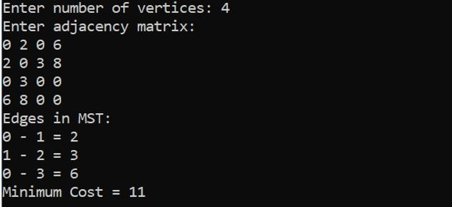

Lab program 8b:
Find Minimum Cost Spanning Tree of a given undirected graph using Kruskal’s algorithm.

#include <stdio.h> #include <stdlib.h>

struct Edge
{
int src, dest, weight;
};

struct Subset
{
int parent;
};

int find(struct Subset subsets[], int i)
{
while (subsets[i].parent != i) i = subsets[i].parent;

return i;
}

void Union(struct Subset subsets[], int x, int y)
{
int xroot = find(subsets, x); int yroot = find(subsets, y);

subsets[xroot].parent = yroot;
}

int compare(const void *a, const void *b)
{
return ((struct Edge *)a)->weight - ((struct Edge *)b)->weight;
}

void KruskalMST(struct Edge edges[], int V, int E)
{
struct Edge result[V];

struct Subset subsets[V];
qsort(edges, E, sizeof(struct Edge), compare); for (int i = 0; i < V; i++)
subsets[i].parent = i;

int e = 0; int i = 0;

while (e < V - 1 && i < E)
{
struct Edge next = edges[i++];

int x = find(subsets, next.src); int y = find(subsets, next.dest);

if (x != y)
{
result[e++] = next;
Union(subsets, x, y);
}
}

printf("\nEdges in MST:\n"); int total = 0;
for (i = 0; i < e; i++)
{
printf("%d -- %d == %d\n", result[i].src, result[i].dest, result[i].weight);

total += result[i].weight;
}

printf("Total Cost = %d\n", total);
}

int main()
{

int V;

printf("Enter number of vertices: "); scanf("%d", &V);

int E = V * (V - 1) / 2; struct Edge edges[E];
printf("Enter edges (src dest weight):\n");

for (int i = 0; i < E; i++)
{
scanf("%d %d %d", &edges[i].src, &edges[i].dest, &edges[i].weight);
}

KruskalMST(edges, V, E);

return 0;
}

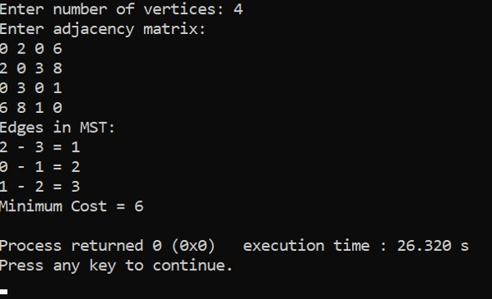
Output:

Lab program 9:
Implement Fractional Knapsack using Greedy technique

#include <stdio.h> struct Item
{
int weight; int value;
};

int main()
{
int n, capacity;

printf("Enter number of items: "); scanf("%d", &n);
struct Item items[n]; for(int i = 0; i < n; i++)
{
printf("Enter weight and value of item %d: ", i + 1); scanf("%d %d", &items[i].weight, &items[i].value);
}

printf("Enter knapsack capacity: "); scanf("%d", &capacity);

double ratio[n];

for(int i = 0; i < n; i++)
ratio[i] = (double)items[i].value / items[i].weight;

for(int i = 0; i < n - 1; i++)
{
for(int j = i + 1; j < n; j++)
{
if(ratio[i] < ratio[j])
{
double tempR = ratio[i];

ratio[i] = ratio[j]; ratio[j] = tempR;
struct Item temp = items[i]; items[i] = items[j];
items[j] = temp;
}
}
}

double maxValue = 0.0; int remaining = capacity;

for(int i = 0; i < n; i++)
{
if(items[i].weight <= remaining)
{
remaining -= items[i].weight; maxValue += items[i].value;
}
else
{
maxValue += ratio[i] * remaining; break;
}
}

printf("Maximum value in Knapsack = %.2f\n", maxValue);

return 0;
}

Output:
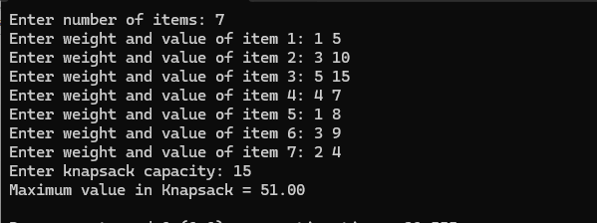

Leetcode 455:Assign Cookies

#include <stdlib.h>

int compare(const void *a, const void *b) { return (*(int *)a - *(int *)b);
}

int findContentChildren(int* g, int gSize, int* s, int sSize) {

// Sort greed factors and cookie sizes qsort(g, gSize, sizeof(int), compare); qsort(s, sSize, sizeof(int), compare);

int i = 0; // children pointer int j = 0; // cookies pointer

while (i < gSize && j < sSize) { if (s[j] >= g[i]) {
i++;
} j++;
}

return i;
}455

Output:

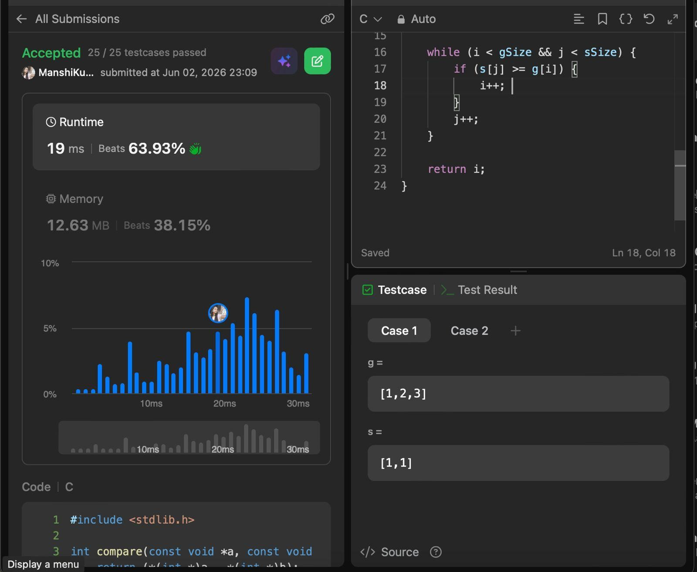

Lab program 10:
From a given vertex in a weighted connected graph, find shortest paths to other vertices using Dijkstra’s algorithm.

#include <stdio.h> #include <limits.h>

#define V 10

int minDistance(int dist[], int sptSet[], int vertices)
{
int min = INT_MAX, min_index;

for (int v = 0; v < vertices; v++)
{
if (sptSet[v] == 0 && dist[v] <= min)
{
min = dist[v]; min_index = v;
}
}

return min_index;
}

void printSolution(int dist[], int vertices, int src)
{
printf("Vertex \t Distance from Source %d\n", src);

for (int i = 0; i < vertices; i++)
{
printf("%d \t %d\n", i, dist[i]);
}
}

void dijkstra(int graph[V][V], int src, int vertices)
{
int dist[vertices]; int sptSet[vertices];

for (int i = 0; i < vertices; i++)
{

dist[i] = INT_MAX; sptSet[i] = 0;
}

dist[src] = 0;

for (int count = 0; count < vertices - 1; count++)
{
int u = minDistance(dist, sptSet, vertices); sptSet[u] = 1;

for (int v = 0; v < vertices; v++)
{
if (!sptSet[v] && graph[u][v] &&
dist[u] != INT_MAX && dist[u] + graph[u][v] < dist[v])
{
dist[v] = dist[u] + graph[u][v];
}
}
}

printSolution(dist, vertices, src);
}

int main()
{
int vertices;

printf("Enter number of vertices: "); scanf("%d", &vertices);

int graph[V][V];
printf("Enter adjacency matrix (0 if no edge):\n"); for (int i = 0; i < vertices; i++)
{
for (int j = 0; j < vertices; j++)
{
scanf("%d", &graph[i][j]);
}

}

int src;

printf("Enter source vertex: "); scanf("%d", &src);

dijkstra(graph, src, vertices);

return 0;
}

Output:

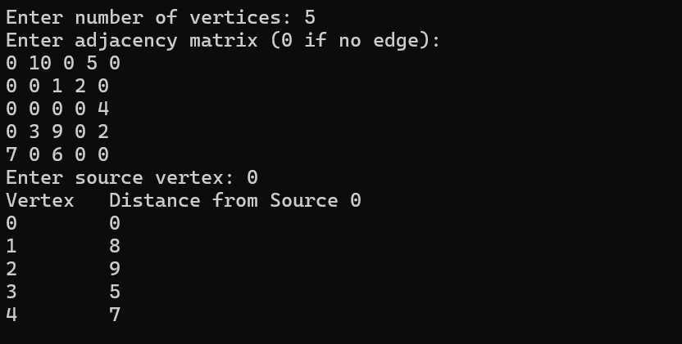

Lab program 11:
Implement “N-Queens Problem” using Backtracking.

#include <stdio.h> #include <stdbool.h>
#define MAX 20 int N;
int board[MAX][MAX];

bool isSafe(int row, int col)
{
for(int i = 0; i < row; i++)
{
if(board[i][col]) return false;

if(col - (row - i) >= 0 && board[i][col - (row - i)]) return false;

if(col + (row - i) < N && board[i][col + (row - i)]) return false;
}

return true;
}

void printBoard()
{
for(int i = 0; i < N; i++)
{
for(int j = 0; j < N; j++)
printf("%c ", board[i][j] ? 'Q' : '.');

printf("\n");
}

printf("\n");

}

void solve(int row)
{
if(row == N)
{
printBoard(); return;
}

for(int col = 0; col < N; col++)
{
if(isSafe(row, col))
{
board[row][col] = 1;

solve(row + 1);

board[row][col] = 0;
}
}
}

int main()
{
printf("Enter the size of the board (N): "); scanf("%d", &N);

if(N > MAX || N < 1)
{
printf("Invalid board size. Please enter between 1 and %d.\n", MAX); return 1;
}

solve(0);

return 0;
}

Output:
